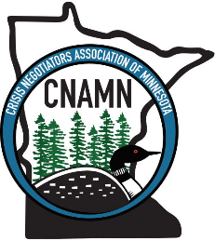
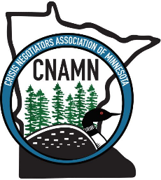
CRISIS NEGOTIATORS ASSOCIATION OF MINNESOTA
STATE CONFERENCE

NEGOTIATION OF THE YEAR AWARD

The Negotiation of the Year Award is awarded annually to the negotiation team that demonstrates excellence during a negotiation event. Factors considered during an event may include exceptional teamwork, tactics, communication, innovation, and resolution. The selected team may be asked to do a case presentation during this years or next year’s state conference.

*This nomination form must be received by May 1st of each year.
**Email completed form to the Crisis Negotiators Association of Minnesota at: info@cnamn.org

Team Name:

Person Submitting Nomination Form (name and email address):

Today’s Date:

Date of Incident (Last calendar year):

Location of Incident:

Team Members and Roles:

Event Details:

Highlight specific details or reasons as to why this incident is worthy of the Negotiation of the Year Award:

